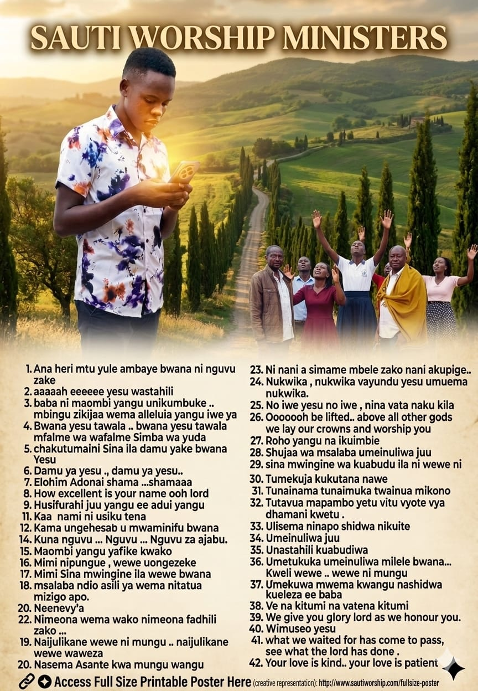

SAUTI WORSHIP MINISTERS:
GOOD WORSHIP SONGS;
- Ana heri mtu yule ambaye bwana ni nguvu zake
- aaaaah eeeeee yesu wastahili
- baba ni maombi yangu unikumbuke .. mbingu zikijaa wema alleluia yangu iwe ya Kwanza
- Bwana yesu tawala .. bwana yesu tawala mfalme wa wafalme Simba wa yuda
- chakutumaini Sina ila damu yake bwana Yesu
- Damu ya yesu ., damu ya yesu..
- Elohim Adonai shama ...shamaaa
- How excellent is your name ooh lord
- Husifurahi juu yangu ee adui yangu
- I surrender ooh , I surrender all.
- Kaa nami ni usiku tena
- Kama ungehesabu makosa nani angesimama
- Kila siku kila saa u mwaminifu bwana
- Kuna nguvu ... Nguvu ... Nguvu za ajabu.
- Maombi yangu yafike kwako
- Mimi nipungue , wewe uongezeke
- Mimi Sina mwingine ila wewe bwana
- msalaba ndio asili ya wema nitatua mizigo apo.
- Naijulikane wewe ni mungu .. naijulikane wewe waweza
- Nasema Asante kwa mungu wangu
- Neenevy'a
- Nimeona wema wako nimeona fadhili zako ...
- Ni nani a simame mbele zako nani akupige..
- Nukwiika , nukwiika vayundu yesu umuema nukwiika.
- No iwe yesu no iwe , nina vata naku kila muthenya
- Ooooooh be lifted.. above all other gods we lay our crowns and worship you
- Roho yangu na ikuimbie
- Shujaa wa msalaba umeinuliwa juu
- sina mwingine wa kuabudu ila ni wewe ni wewe bwana
- Tumekuja kukutana nawe
- Tunainama tunaimuka twainua mikono tunakwabudu
- Tutavua mapambo yetu vitu vyote vya dhamani kwetu .
- Ulisema ninapo shidwa nikuite
- Umeinuliwa juu
- Unastahili kuabudiwa
- Umetukuka umeinuliwa milele bwana... Kweli wewe .. wewe ni mungu
- Umekuwa mwema kwangu nashidwa kueleza ee baba
- Ve na kitumi na vatena kitumi
- We give you glory lord as we honour you.
- Wimuseo yesu
- what we waited for has come to pass, see what the lord has done .
- Your love is kind.. your love is patient

COMPILED BY : MINISTER BONFACE
#GOD”S GRACE IS SUFFICIENT
FOR MORE INFORMATION:
CALL:0703870109
WATTSAPP:0703870109

